Assignment 1

**Kali Linux**

To begin, I downloaded the .iso disk image from the Kali Linux webpage. I checked the requirements for Kali Linux to be installed, which was 20GB of disk space and 2 GB of RAM. A screenshot of a computer

After that, I created a new VM in VirtualBox, gave it 2 GB of RAM and a dynamically allocated 20GB of disk space.

I powered up the machine at that point and input the disk image.

This started the install and I selected graphical installer so I could navigate most easily. I worked through the installation, mostly just using the suggested settings and setting myself up as a user. 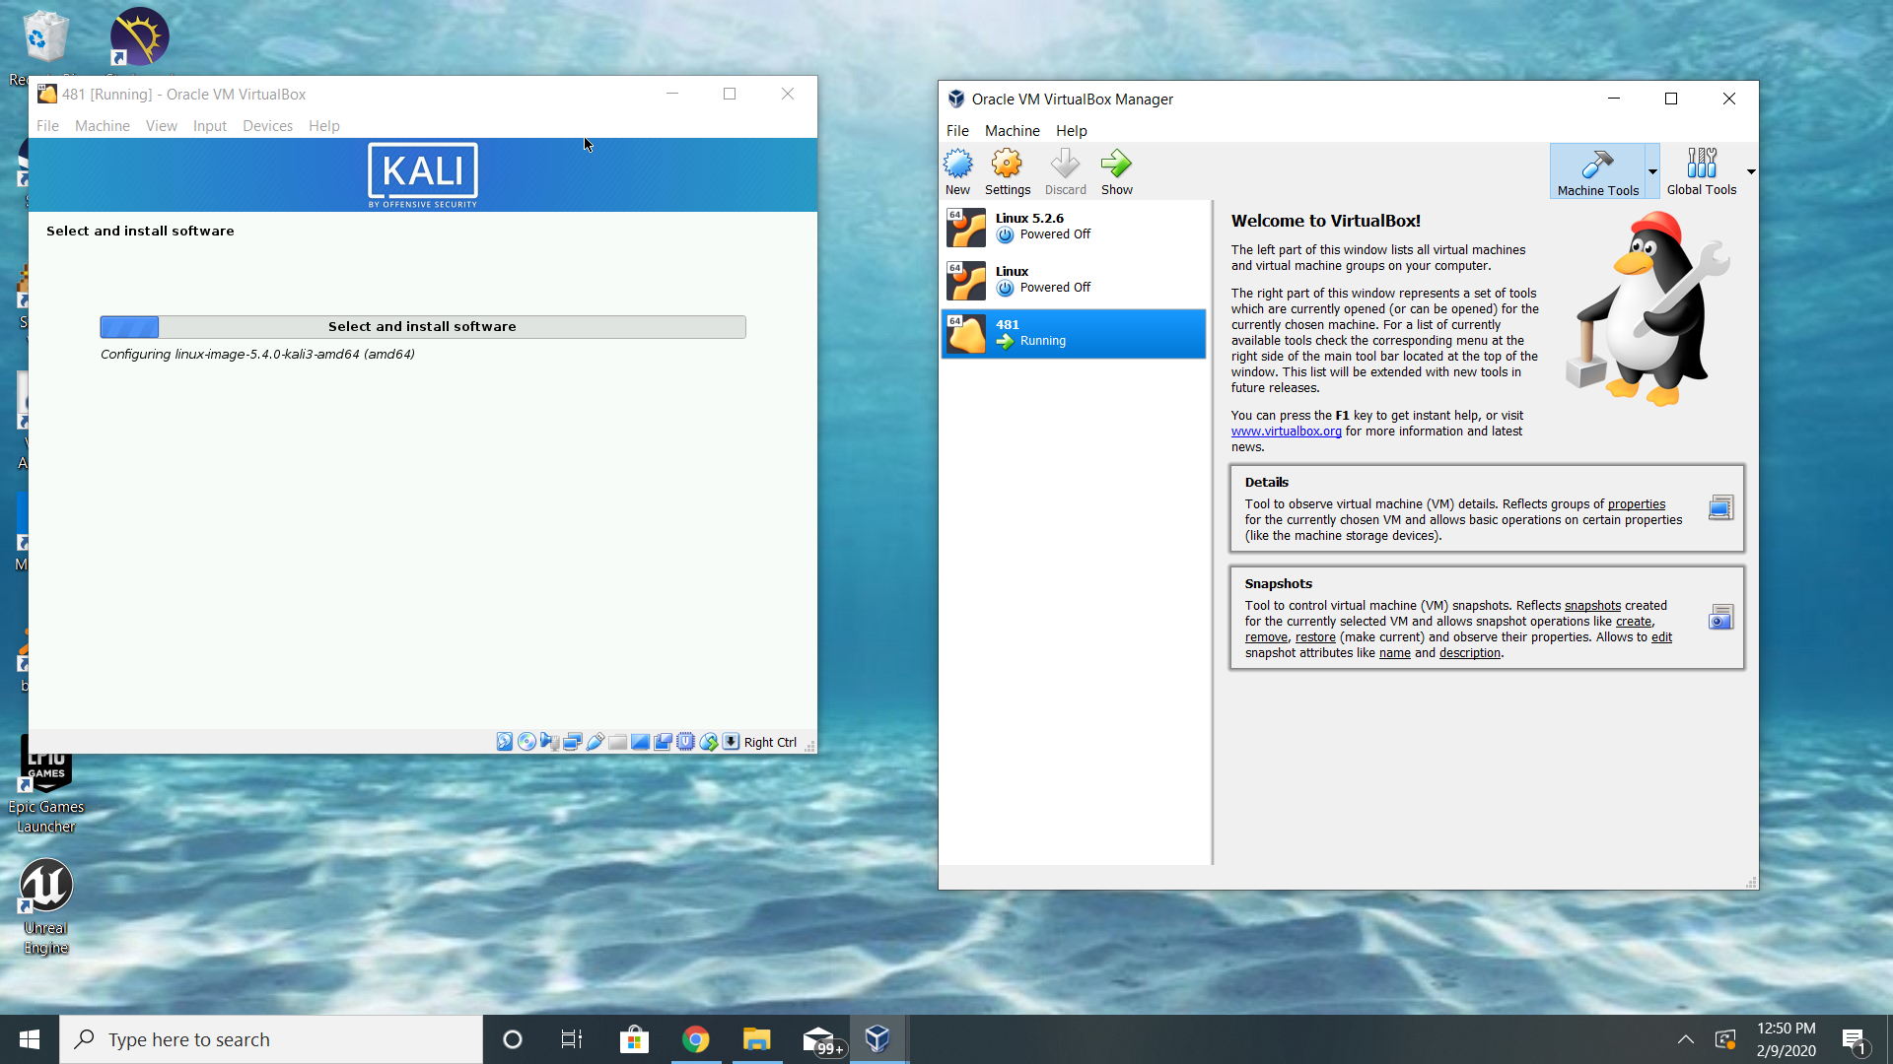

Once I’d finished the installer, I was able to boot up Kali Linux and run it.

**Windows 10**

To start, since I’m already using a Windows machine, I had to download and install the media creation tool. I used this to create a Windows 10 iso file.

Then, I created another virtual machine on VirtualBox. This one I made with the same specifications, 2 GB of RAM and 20 GB of dynamically allocated disk space.

Upon starting it for the first time, it prompted me to begin the windows installation, so I just walked through the installation. I did an installation of Windows only and when it was completed I had to sign in and had a working Windows 10 desktop.

